

**CS 319**

**Object-Oriented Software**

**Engineering Project**

**Final Report**

**Section 2 / Group 2K**

**Ege Darçın**

**Alptuğ Albayrak**

**Özgün Özkan**

**Furkan Erdem**

**Instructor: Bora Güngören**

1) Introduction

2) Installation

3) GamePlay

3.1) Main Menu:

3.2) Player Select Menu:

3.3) Settings Menu:

3.4) Credits Menu:

3.5) How to Play Menu:

3.6) In Game Screen:

4) Non Implemented Specifications and Changes

5) Class Descrıptıon 11

## 1) Introduction

Headball is a 2D arcade game. The game will basically start with the main menu which includes play,settings, credits, how to play and exit sections. Before starting the game, user is going to have an option to choose his/her favorite character to play. Main object of the game is to score against the other player and to make higher score than the other player when the given time is finished. When the game starts, there will be two goals on each sides and the football players will begin the game infront of their goals. A ball will appear in the middle of the field and each player is going to try to hit the ball to score. In order to make the game more enjoyable, there will be different modes(normal and the random mode) and powerups. There will be different power ups such as fast movement and fireball which will be able to used by the player when the user triggers the related powerup via a key binded to it. The current score is always going to be displayed and updated on the provided scoreboard.

## 2) Installation

Java Runtime Environment has to be installed on the computer to run the game. By opening the project and importing jbox2d libraries the game is ready to play. On the demo, a compacted version will be ready for the usage.

## 3) GamePlay

**Menus:**

### 3.1) Main Menu:



Main menu consists of five buttons:

* **Play**: Opens the player select menu.
* **Settings**: User can change sound settings from this menu.
* **Credits**: Shows the names of the people who worked on the game.
* **How to Play**: Shows key bindings.
* **Exit**: Exits the game.

### 3.2) Player Select Menu:

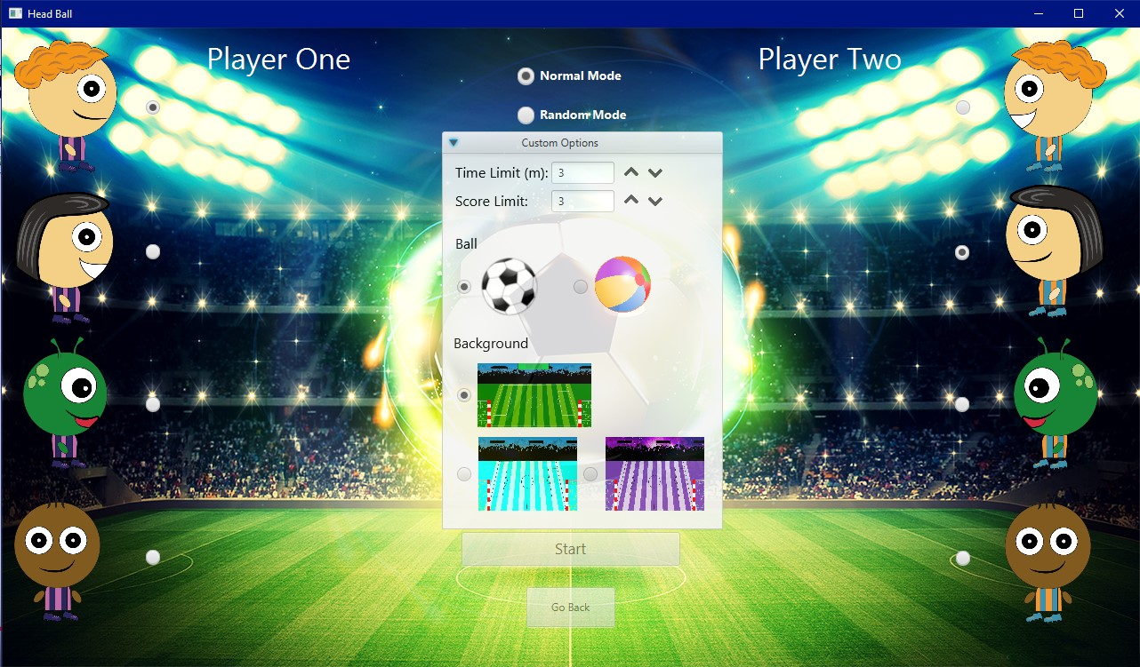

Player select menu consists of two buttons, four radio buttons group and 4 buttons to change limits.

* **Player One Select:** First user can select his character from these 4 different avatars. Default is the first avatar. This player’s goal will be on the left side.
* **Player Two Select:** Second user can select his character from these 4 different avatars. Default is the second avatar. This player’s goal will be on the right side.
* **Game Mode Select:** Players can select different game modes from here. Default is “Normal”. The other is “Random Mode”
* A scroll bar is present for custom options. The user can select time and score limit (max is 9), ball type and background here if normal mode selected. If random mode selected the user cannot change ball type and background.
* **Start:** Starts the game with the selected avatars and mode.
* **Go Back:** Returns to the previous menu (main menu).

### 3.3) Settings Menu:



Settings menu consist of one checkbox and one button:

* **Sound:** User can turn on/off the sound of the game. On by default.
* **Go Back:** Returns to the previous menu (main menu).

### 3.4) Credits Menu:

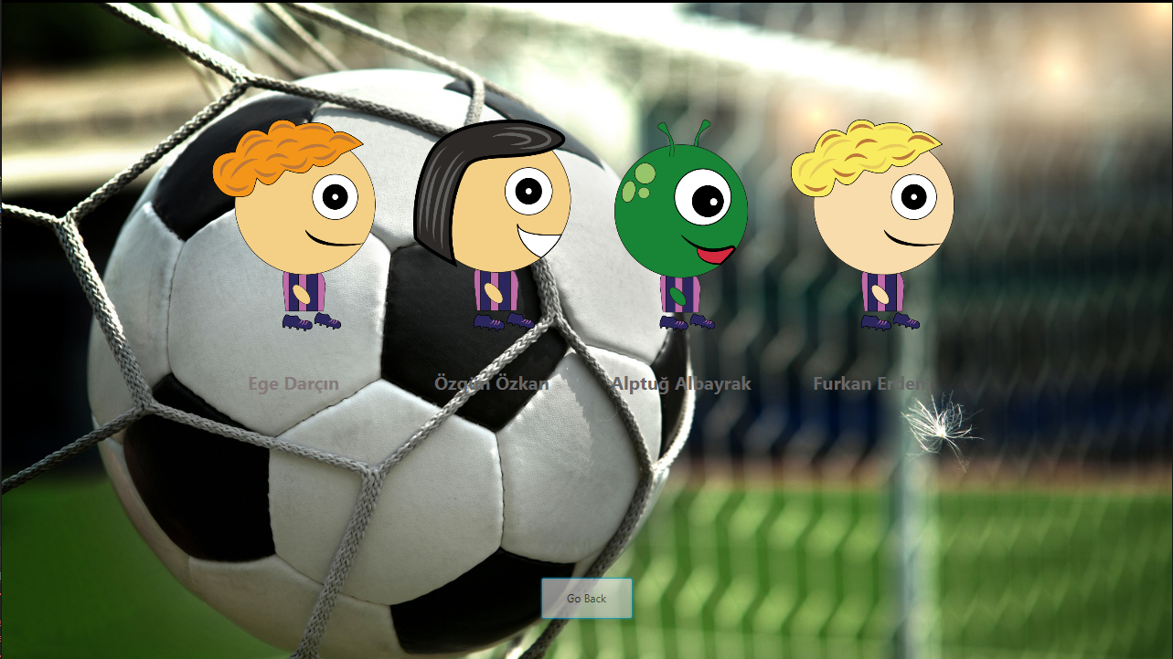

Credits menu consist of group member names and a “Go Back” button to return to the previous menu.

### 3.5) How to Play Menu:

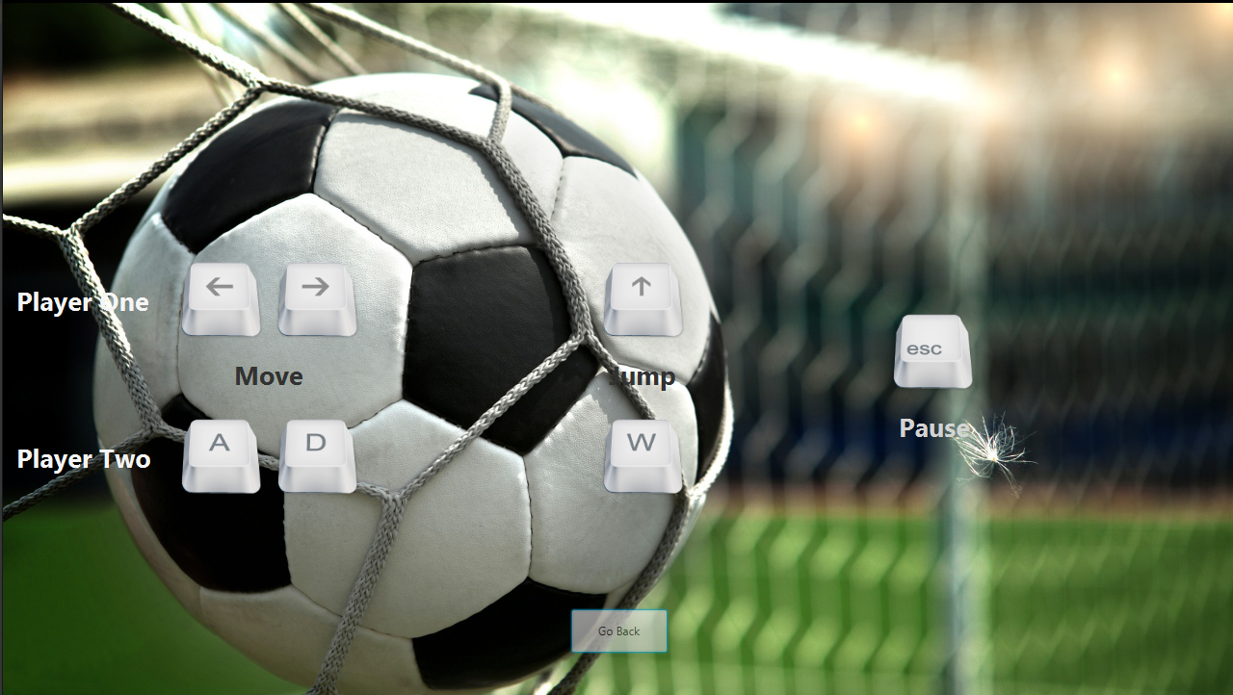

How to play menu consist of key bindings of the game and a “Go Back” button to return to the previous menu.

### 3.6) In Game Screen:

In the game, players will use their headballers to score goals. With arrow keys and w,a, s and d, players command their headballers to score goals.

There are two different balls and three different scenes. The foootball ball is a normal ball with normal physics and the beach ball is the wacky ball, where it has different physics such as higher damping and unpredictable stops when it touches the ground.

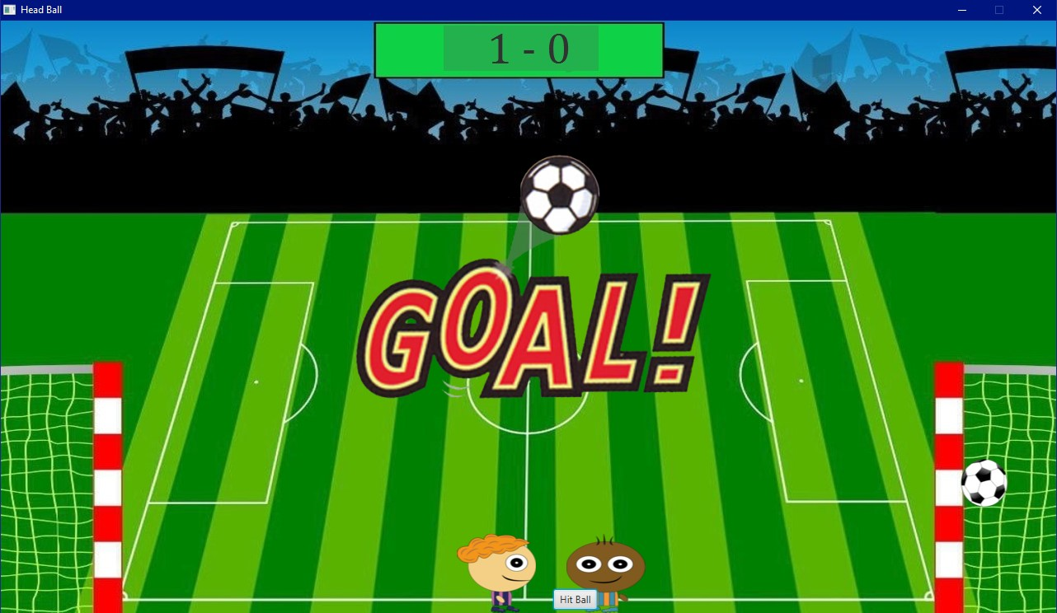

The first scene is the normal scene, where physics are normal and players combat in a normal manner.

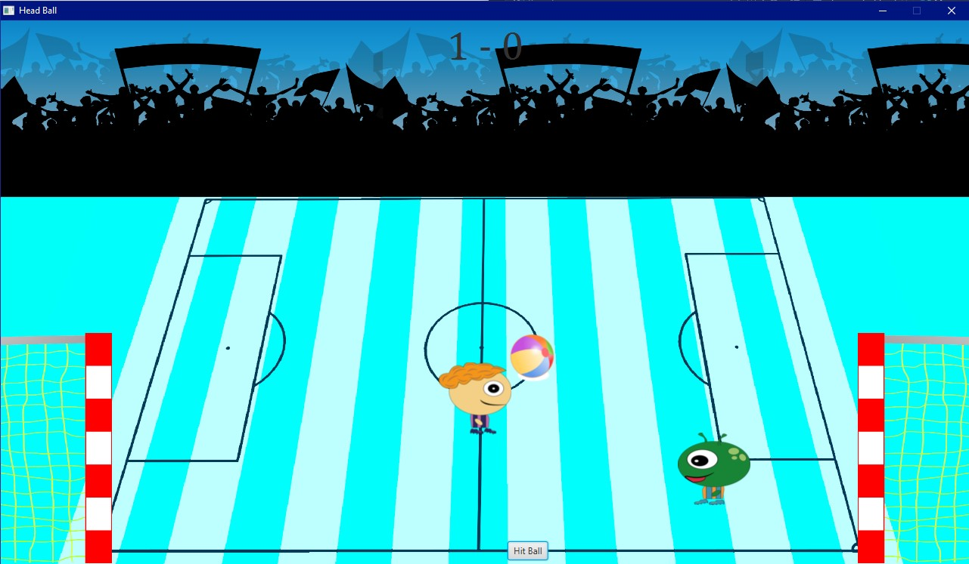

The second scene is the ice scene, where there is little to no friction. It is harder to control the ball and players.

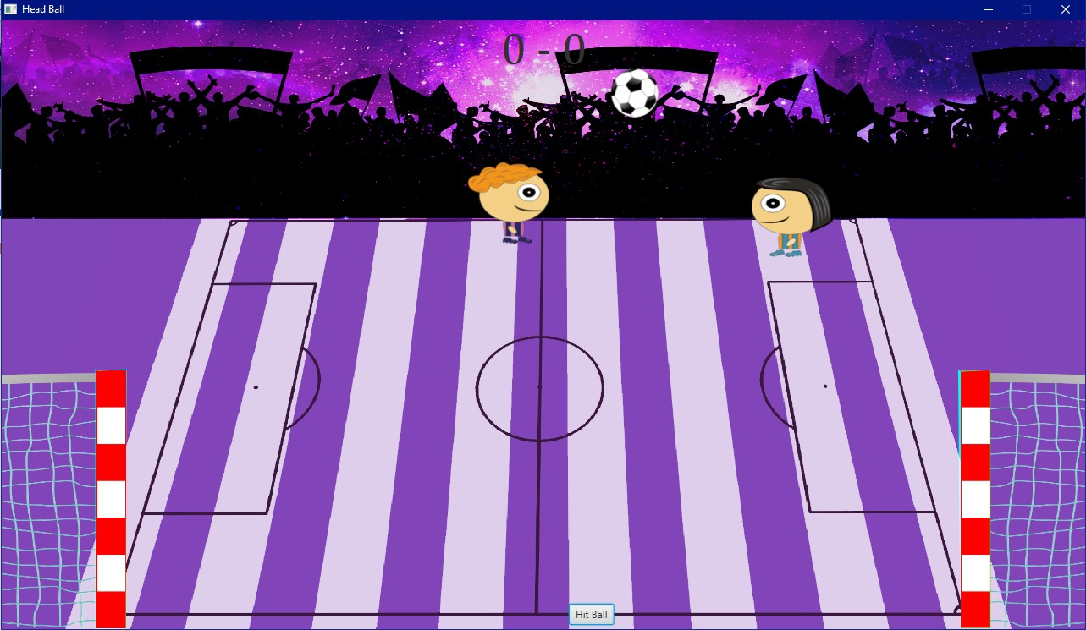

The third scene is the space scene where there is no gravity, this configuration makes the ball and headballers to move wherever they want and by using the borders they move faster, like the astronauts grabbing walls to navigate in the spaceship.

If players press escape or click the icon on the top left of the screen, options menu will pop up and bring out the pause menu.

The game ends in three ways: draw, p1 win and p2 win. If the score limit is reached, the player who reached wins. If the time runs out, the player who scored most goal wins. If the goal numbers are equal, it is a draw.

## 4) Non Implemented Specifications and Changes

Changes: Sound added in the game, for each round the cheering goes on.

Collision Listener class is added in order to detect and control the collisions between bodies.

Here is the updated class diagram:

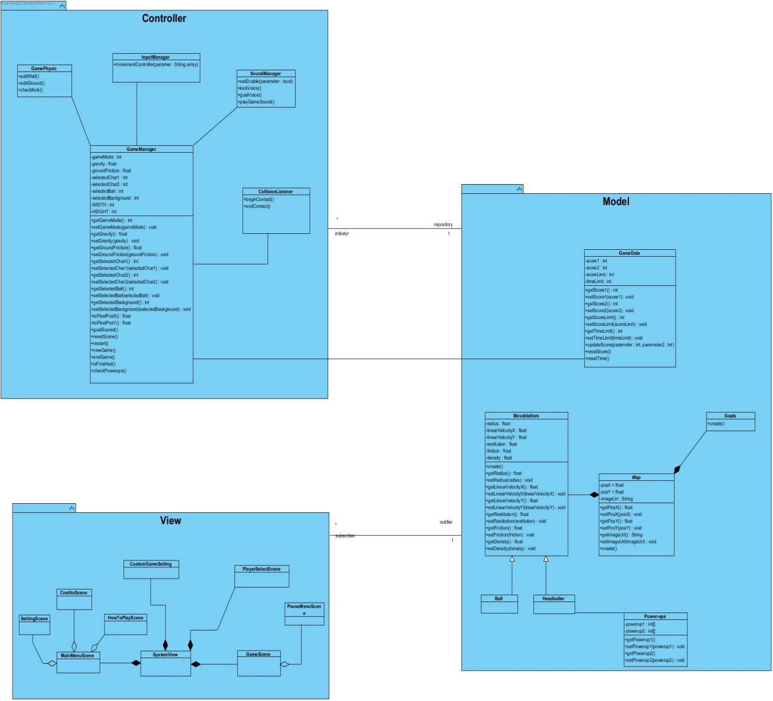

## 4.1) Class Descriptions

### 4.1.1) Controller Package

### 4.1.1.1) GameManager Class

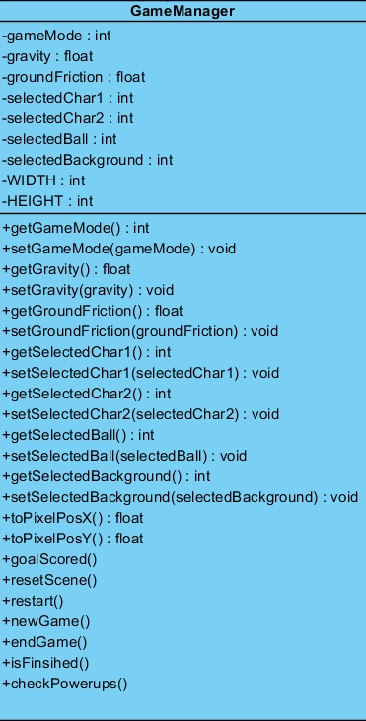

This class handles almost everything about the game. It provides connections between game data and display. It allows program to sets physical world behind the vision and to gives values to physical variable which affects how physical objects behave. It organizes and conducts main process of the game such as ending and starting game. In these methods all variables and objects are set to appropriate values and states according to process.

**Attributes:**

**gameMode:** This variable gets value from View according which mode player prefers to play.

**gravity:** This variable holds value of gravity of the world which is defined through the jbox2D library. During game this variable may get different values in different game modes. It needs to be set to different values and got by different methods.

**groundFriction:** This variable holds value of friction of the ground. During game this variable may get different values in different game modes. For example, with ice ground, its value would be lower than default friction. It needs to be set to different values and got by different methods.

**selected … :** These whole variables starting with selected get different values according to player preferences. When ball or headballer selection change, it gets different values and implies different attributes.

**WIDTH and HEIGHT:** They are both final values which can not be changed. They are set by programmer to default values according to screen size. Both world and game scene would be affected by values of these variables.

**Operations:**

**toPixelPosX():** Thismethod provides an algorithm which convert javafx pixel coordinates to world coordinates which is defined through jbox2d library utilized for visualizing physical motion and collision more accurately.

**toPixelPosY():**Thismethod provides an algorithm which convert javafx pixel coordinates to world coordinates which is defined through jbox2d library utilized for visualizing physical motion and collision more accurately.

**goalScored():** That method checked whether goal is occurred for one of the goals. Then realize necessary operations after goal is detected. It updates score, calls resetScene() method and necessary voice methods.

**resetScene():** It resets the scene appropriately. It re- locates the game object to their default places.

**restart():** It is called when restart button is pressed. It re-initializes the game and game objects. It resets default values of physical attributions of the game object. It reset the game data such as score and time.

**newGame():** It creates new world through the jbox2D library. And it puts two headballers and ball with preferred physical and visual attribution according to gameMode.

**endGame():** It is called when game is over. It destroys the world which is created initially game object placed in. And other values set to default to prevent some confliction which may be arisen when user wants to play new game in different game mode.

**isFinished():** This method checks whether game is over or not. It looks both time and score limit by getting current values of them from GameData class in the Modal. And it call endgame() method according to situation.

**checkPowerups():** It checks which power-ups are activated. According to activated power ups, it changes and updates values of physical attributions of the game objects including ball and headballers.

### 4.1.1.2) InputManager Class

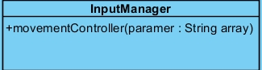

**Operation**

**movementController:** It gets keyboard inputs from the listeners of the game scene and it realize appropriate movements and calls suitable method in GameManager to change and update physical attributions of the objects when it is needed.

### 4.3.1.3) GamePhysic Class

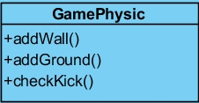

This class would be needed when world is being built and to detect occurrences of some of physical situations to call appropriate methods.

**Operations**

**addWall() :** This method is utilized when new game and world is built. It adds wall with given position, width and height to jbox2d world

**addGround():**This method is utilized when world is built. It adds ground with given friction and height.

**checkKick(): I**t checks whether there is collision or contact between one of headballers and ball and calls SoundManager methods.

### 4.1.1.4) SoundManager Class

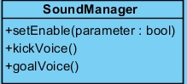

**Operations**

**setEnable():** It get value from the GameManager according to option value of sound preferred by the user and it enables or deactivates sound during the game.

**goalVoice() and kickVoice() :** They may both get activated(called) by GameManager to sound appropriate voice.

### 4.1.2) View Package

Here, methods are in FXML to control the GUI. So, instead of classes, we are demonstrating which class has which FXML files and show what they do.

### 4.1.2.1) Main_Menu_Controller Class

**Operations:**

@FXML private void openPlayerSelect (ActionEvent event): Changes the scene to player select menu.

@FXML private void openOptions (ActionEvent event): Changes the scene to options menu.

@FXML private void openCredits (ActionEvent event): Changes the scene to credits menu.

@FXML private void openHowToPlay (ActionEvent event): Changes the scene to how to play menu.

@FXML private void exit (ActionEvent event): Exits the program.

### 4.1.2.2) PlayerSelect_Controller Class

**Attributes:**

@FXML private ToggleGroup playerOne: The radio button group for the first player.

@FXML private ToggleGroup playerTwo: The radio button group for the second player.

@FXML private ToggleGroup gameMode: The radio button group for the game modes.

**Operations:**

@FXML private void Start(ActionEvent event): Starts the game by sending the player and game modes selections to game manager and changing the scene.

@FXML private void goBack(ActionEvent event): Changes the scene to main menu.

### 4.3.2.3) Options_Controller Class

### Operations:

@FXML private void goBack(ActionEvent event): Changes the scene to main menu.

### 4.3.2.4) HowToPlay_Controller Class

**Operations:**

@FXML private void goBack(ActionEvent event): Changes the scene to main menu.

### 4.3.2.5) Credits_Controller Class

**Operations:**

@FXML private void goBack(ActionEvent event): Changes the scene to main menu.

### 4.1.3) Modal Package

### 4.3.3.1) Map Class

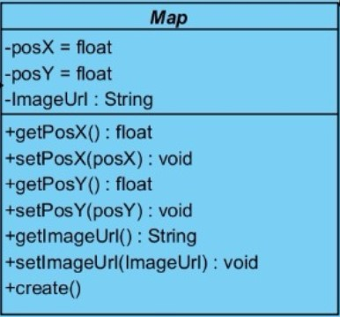

Map class is an abstract class which handles map data for Goals and MovableItem classes.

**Variables:**

**Posx :** position data of an object on X axis is kept here.

**Posy :** position data of an object on Y axis is kept here.

I**mageUrl :** url links of images of objects are kept here.

**Methods:**

**getPosX() :** gets the object’s position on X axis.

**getPosY() :** gets the object’s position on Y axis.

**setPosX(posX) : void :** updates the position of an object on X axis by getting the posX value.

**setPosY(posY): void :** updates the position of an object on X axis by getting the posX value.

**getImageUrl() :** gets the proper url of an image.

**create():** abstract method for building each object to the scene.

### 4.1.3.2) Ball Class

Ball class extends MovableItem, methods are same but the variables are different for each ball.

### 4.1.3.3) Headballer Class

Headballer class extends MovableItem, methods are same, like ball but headballers have different variablers and attributes.

### 4.1.4.4) Goals Class

Goals class is for creating goals on the game scene. They are invisible objects on the map and are fixed to their locations. This enables us to use the top pole of the game efficiently .

**Methods:**

**create():** This is the method for creating goals on the scene.

### 4.1.4.5) GameData Class

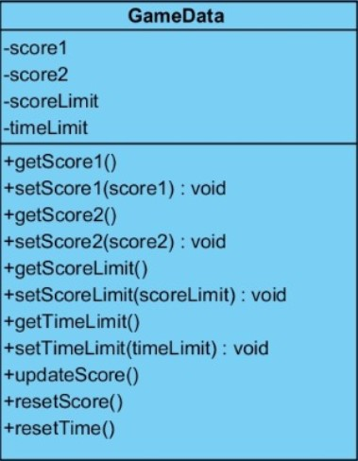

**Variables:**

**score1 :** Score of the first player

**score2 :** Score of the second player

**scoreLimit :** Highest achievable score by a player is kept here.

**timeLimit :** Duration limit of the game is kept here.

**Methods:**

**getScore1(): int :** returns the score of the first player

**setScore1(score1):void :** Sets the score value to the score of the first player.

**getScore2(): int :** returns the score of the second player

**setScore2(score2):void :** Sets the score value to the score of the second player.

**getScoreLimit():int :** Returns the highest score possible.

**setScoreLimit(scoreLimit):void :** Sets the value of scoreLimit.

**getTimeLimit():int :** Returns the duration limit of the game.

**setTimeLimit(timeLimit):void :** Sets the timelimit before starting the game.

**updateScore(parameter:int,parameter2:int) :** Changes the scoreboard whenever one of the players score.

**resetScore() :** Resets the scores.

**resetTime() :** Resets the time.

### 4.1.4.6) MovableItem Class

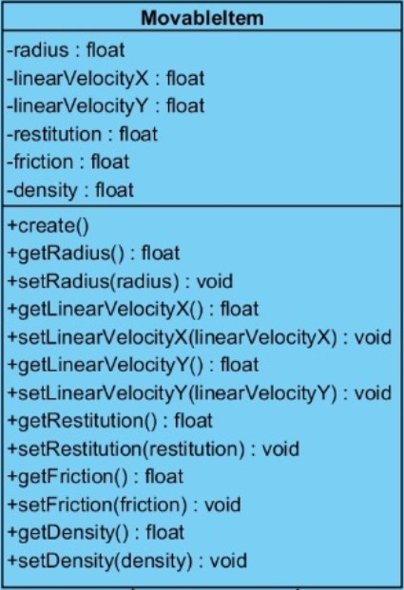

**Variables:**

**Radius:float :** Since we define the head of the players and ball as circle, we keep radius of the circle.

**linearVelocityX:float :** Velocity in the horizontal direction

**linearVelocityY:float :** Velocity in the vertical direction.

**restitution:float :** This is the restititution of objects, which affect the bounciness (i.e. ball)

**friction:float :** friction of objects in the scene is kept here.

**density:float :** density is an important coefficient about jumping calculations and kept here.

**Methods:**

**create()** : Creates the objects when the method is invoked.

**getRadius():float :** returns the radius value for the circles.

**setRadius(radius):void :** Sets the radius value to the taken parameter.

**getLinearVelocityX():float :** returns the velocity in the horizontal direction.

**setLinearVelocityX(linearVelocityX):void :** Sets the horizontal velocity value to taken parameter.

**getLinearVelocityY():float :** Returns the velocity value in the vertical direction.

**setLinearVelocityY(linearVelocityY):void :** Sets the vertical velocity to taken parameter.

**getRestitution():float :** returns the restitution of an object.

**setRestitution(restitution):void :** sets the restitution of an object.

**getFriction() :** Returns the friction value.

**setFriction(friction):void :** Sets the friction value to taken parameter.

**getDensity() :** Returns the density value

**setDensity(density):void :** Sets the density value to taken parameter